California State University Fullerton

CPSC 462



Object Oriented Software Design

Use Case Model – Annex 1

for the



Hotel Reservation

System

Manage Hotel Room Listing

Fully Dressed Use Case

|  |  |  |
| --- | --- | --- |
|  | **Josh Ibad** |  |
|  | Chief Software Architect |  |
|  | [joshcibad@csu.fullerton.edu](mailto:joshcibad@csu.fullerton.edu?subject=Regarding the HotelBuch System) |  |

Revision History:

| Version | Date | Summary of Changes | Author |
| --- | --- | --- | --- |
| 1.0 | 2021-10-18 | * Initial Release | Josh Ibad |
| 2.0 | 2021-11-15 | * Changed role to Chief Software Architect * Changed Use Case Scope from "System Use Case" to plainly "System" * Added a fourth step in the main success scenario - getHotelRoom. | Josh Ibad |

**Table of Contents**

1 Use Case Description 2

1.1 Use Case Title 2

1.2 Scope 2

1.3 Category 2

1.3.1 Risks addressed 2

1.4 Level 2

1.5 Primary Actor(s) 2

1.6 Stakeholders and Interests 2

1.6.1 Hotel CEO 2

1.6.2 Hotel's Private Equity Investor 2

1.6.3 Hotel Manager 2

1.6.4 Hotel Clerk 2

1.6.5 Guest 2

1.7 Preconditions (Entrance Criteria) 2

1.8 Success Guarantee (Exit State) 2

1.9 Main Success Scenario 3

1.10 Extensions (Alternate paths) 4

1.11 Special Requirements 4

1.12 Technology and Data Variations List 4

1.13 Frequency of Occurrence 4

1.14 Miscellaneous 4

2 System Sequence Diagrams 5

2.1 Add Room 5

2.1.1 Scenario Description 5

2.1.2 System Sequence Diagram 5

2.2 Modify Room 6

2.2.1 Scenario Description 6

2.2.2 System Sequence Diagram 6

# Use Case Description

## Use Case Title

Manage Hotel Room Listing

## Scope

System

## Category

Architecturally Significant

### Risks addressed

1. Risk 4 - Erroneous Input: Management of Hotel Room Listing will be done through an intuitive interface with confirmation system to minimize erroneous input.

## Level

User Goal

## Primary Actor(s)

* Hotel Manager

## Stakeholders and Interests

### Hotel CEO

Being able to manage hotel room listings will greatly improve hotel system managability and business operability. This makes it more convenient for hotel staff to operate and organize the business better.

### Hotel's Private Equity Investor

Management of hotel room listings allow for flexible hotel room descriptions and price. This allows a hotel to remain competitive and to adjust to the state of the market. This also allows an easy management of the marketability of these hotel rooms. All of this results in an increase in visitors and revenue of which the investor gets a share.

### Hotel Manager

The feature to manage hotel room listings directly makes the hotel management process more convenient for the hotel manager. They can easily adjust room descriptions and prices as registered on the system.

### Hotel Clerk

The clerk wants to be able to see an updated and descriptive list of hotel rooms in the system on which to accomodate guest and to provide said description to guests checking in.

### Guest

The guests wants to see an update and descriptive list fo hotel rooms available at their desired time. They want to see what features the hotel room has and how much it will cost them.

## Preconditions (Entrance Criteria)

Hotel Manager account is configured with Hotel Manager role access. System is running and reachable from Hotel Manager's client device.

## Success Guarantee (Exit State)

Hotel room management actions (addition/modification/deletion) are saved. Modifications are immediately reflected for immediate reservation and accomodation.

## Main Success Scenario

1. The Hotel Manager requests to connect to the system as a Hotel Manager, providing their username and password. The System responds with a session.
2. The Hotel Manager requests a listing of hotel rooms for the hotel. The System replies with a list of hotel rooms.
3. The Hotel Manager requests to add a hotel room to be registered in the system, providing information such as price, room type, bed type, bed count, and a description. The System replies with a receipt of whether or not the room was succesfully added.
4. The Hotel Manager requests the information of a specific room, giving the room ID of the newly added room. The System replies with the information of the added room, confirming that information is the same as the information entered from earlier.
5. The Hotel Manager requests to terminate their session. The System responds with a receipt of whether or not the session was terminated.

## Extensions (Alternate paths)

3a. Instead, Hotel Manager wants to update an existing room.

1. The Hotel Manager requests to get information about a room, specifying the room desired. The System responds with information about the room.

2. The Hotel Manager requests to update the room, providing the new price, room type, bed type, bed count, and description. The System replies with a receipt of whether or not the room was successfully updated.

3b. Instead, Hotel Manager wants to delete an existing room.

1. The Hotel Manager requests to get information about a room, specifying the room desired. The System responds with information about the room.

2. The Hotel Manager requests to delete the room. The System responds with a receipt of whether or not the room was successfully deleted.

## Special Requirements

Hotel room management must be secure and only accessible to high-trust actors such as the Hotel Manager.

Interface must be intuitive and usable to busy, non-technical personel, like Hotel Manager.

## Technology and Data Variations List

1-4. The Hotel Reservation System must provide an intuitive graphical user interface and must support typical peripheral device inputs such as that of mouse, keyboard, and potentially touch screen.

1. Authentication is typed credentials. But within two years, security may improve to include biometrics or RFID tags.

## Frequency of Occurrence

Once per room per financial quarter

Rationale: Room info is changed per financial quarter to readjust business strategy

## Miscellaneous

This feature can be extended to perform with consideration of multiple hotel branches, within which rooms listings are grouped together. A manage hotel branches use case could be derived out of this.

# System Sequence Diagrams

## Add Room

### Scenario Description

The Hotel Manager requests to connect to the system as a Hotel Manager, providing his username "JDoe" and password "ManagersRule1!". The system responds with a session with hotel manager role access. Then, The Hotel Manager requests to get a list of hotel rooms. The system responds with the list of hotel rooms registered with the system, which currently is empty. The Hotel Manager then requests to add a hotel room with a price of $150 per night, of the "Deluxe" room type, with 1 "Queen" bed, and with the description of "Comfy room". The system responds with a receipt of the success of the room creation, returning a "Room added" message. Finally, the Hotel Manager requests to terminate his connetion. The system responds with a receipt of the success of connection termination, returning the success message "Session for JDoe successfully terminated".

### System Sequence Diagram

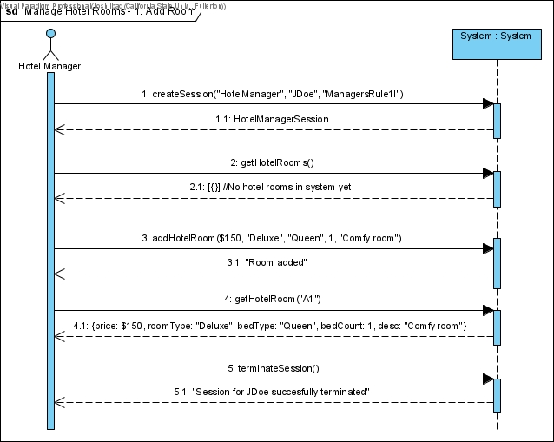

## Modify Room

### Scenario Description

The Hotel Manager requests to connect to the system as a Hotel Manager, providing his username "JDoe" and password "ManagersRule1!". The system responds with a session with hotel manager role access. Then, The Hotel Manager requests to get a list of hotel rooms. The system responds with the list of hotel rooms registered with the system, which currently has a single room labeled "A1". The Hotel Manager then requests to get the information for hotel room "A1". The system responds with the room's info: that the room is $150 per night, is a "Deluxe" room, with 1 "Queen" bed, and with the description that is a "Comfy room". The Hotel Manager requests to update room "A1" with a price of $200 per night, still as "Deluxe" room, but now with 2 "Queen" beds, and a description of a "Comfy room for 2". The system responds with receipt of update success, returning the message "Room A1 modified successfully". Finally, the Hotel Manager requests to terminate his connetion. The system responds with a receipt of the success of connection termination, returning the success message "Session for JDoe successfully terminated".

### System Sequence Diagram

